Specifications for Degree Planning & Audit Application

## Degree Planning Process

### Data Needed from the Transcript:

Get name after **Name:**

For use as **Name of Student** on Degree Plan

For use as **Name** on Audit Report

Get ID number after **Student ID:**

For use as **Student I.D. Number** on Degree Plan

For use as **ID** on Audit Report

After: **Academic Program History**

Program: **Master**

Determine whether **Computer Science** Major or **Software Engineering** Major

for use as **Major** on Audit Report

After **Beginning of Graduate Record** is the date for use as:

**Semester Admitted to Program** for degree plan

Course Data for all courses with CS or SE Prefix with 4-digit numbers that start with 5 or above

Semester Taken:

Data need include prefix: CS or SE

Course number: 4-digit code

Description:

Attempted credits: Typically, 3.000, but should allow for other values

Grade:

Notes:

ECSC 5177: CS IPP Assignment does not count for credit on degree plan. i.e., The application should not include it on the degree plan. It is also not used in the calculation of the GPAs.

Only one of CS 5333, CS 5343, and CS 5348 may be used as elective. Other 5000 level CS/SE courses cannot be counted as electives, but the grades do contribute to overall GPA.

The one of CS 5333, CS 5343, and CS 5348 for which the student earned the highest grade should be placed in the **Additional Electives** section of the Degree Plan.

If the student earned the same score in 2 or more of CS 5333, CS 5343, and CS 5348, use one with those with the higher score by choosing CS 5343 over CS 5333 and CS 5348 as the elective, choosing CS 5348 over CS 5333 as the elective.

See **Graduate Career Totals**

After **Combined Cum GPA**

Save value after **Combined Cum GPA** for comparison with value calculated during for audit part of application

## Data Needed from User:

**The chosen Track (Specialization) of Student**

Current Computer Science Options include the following, but make sure it is easy to add or remove tracks from the application.

* Cyber Security
* Data Science
* Intelligent Systems
* Interactive Computing
* Networks and Telecommunications
* Systems
* Traditional Computer Science

Currently for Software Engineering there is only one Software Engineering. List for selection should only include Software Engineering, but make sure it is easy to add or remove tracks from the application.

**The leveling courses/pre-requisites assigned to the student on admission**

User should be able to specify zero, many, or all of those listed below. Make sure it is easy to add of remove pre-requisites from this list.

* CS 3341 Probability & Statistics in CS and SE
* CS 5303 Computer Science I
* CS 5330 Computer Science II
* CS 5333 Discrete Structures
* CS 5343 Algorithm Analysis & Data Structures
* CS 5348 Operating System Concepts
* CS 5349 Automata Theory
* CS 5354 Software Engineering
* CS 5390 Computer Networks

These should be noted in some form on the degree plan and will be listed on the audit report also. **Note**: The DPEs typically have noted this by highlighting those for the degree plan and listing those for other degree plans. (See Krusty Krab degree plan)

**Whether or not student is pursuing a Fast Track to Masters**

**Whether or not student is pursuing a Thesis Masters**

## Audit Process

The application should have captured the information described above from both the transcript parse and user inputs from degree planning process plus any edits made by the DPE. This can be the starting point for the audit process. i.e., Audit process could start from beginning of degree planning process (i.e., transcript), but could start after degree planning is complete.

The application will calculate and display the core, elective, and combined/overall GPAs on the audit report.

#### Graded Courses

By graded courses we mean courses for which grades other than I, NR, and P are recorded.

#### The Core GPA

The Core GPA is the GPA of the up to five *graded* core classes completed to date.

#### The Elective GPA

The Elective GPA is the GPA of the up to seven *graded* elective classes on the degree plan to date.

Recall your application should only be putting courses with the CS/SE prefix on the degree plan. The user might add a course with a different prefix if it was approved by the program head.

#### The Overall GPA

The overall GPA is the GPA of all *graded* 5000 level or above course taken at the university.

See the UTD graduate catalog for the details of GPA calculations.

<https://catalog.utdallas.edu/2021/graduate/policies/grades#grades-and-grade-point-average>

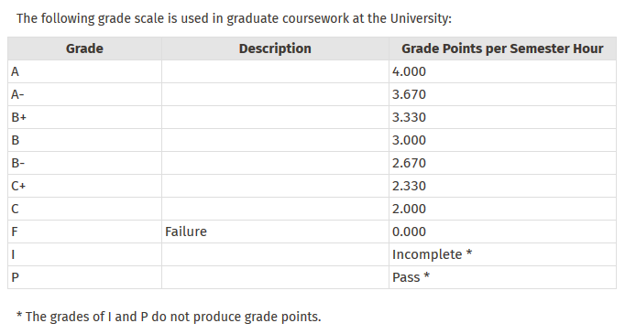

#### Core Course Listing

The application will display the core courses completed to date in the same order they appear on the degree plan. This information should have been captured during the Degree Planning Process.

#### Elective Course Listing

The application will display the elective courses completed to date in ascending order by course number. This information should have been captured during the Degree Planning Process.

#### Leveling Course Listing

The application will list of the pre-requisite/leveling courses given in the admissions letter followed by the disposition of each course. This information should have been captured during the Degree Planning Process. It was entered by the user.

Options selected by User for Disposition could include:

Completed

Waived

Not required by plan or electives

Other

Completed must be followed by the semester of completion. This would appear on the transcript.

Waived and Other should have a field where the user can enter either a semester or short comment.

#### Outstanding Requirements

##### Core GPA

**To graduate the student must have a Core GPA >= 3.19.**

To find the GPA needed in outstanding core courses:

Multiply the graded core semester hours attempted by 3.19 to find the overall grade points that are necessary.

Subtract the grade points earned so far in core courses from grade points necessary and then divide this value by the core credit hours remaining to find GPA needed in remaining core courses.

**A student may graduate with a 3.0 <= Core GPA < 3.19 if they complete an extra 6000+ level CS/SE course.**

Multiply the graded core semester hours attempted by 3.00 to find the overall grade points that are necessary.

Subtract the grade points earned so far in core courses from grade points necessary and then divide this value by the core credit hours remaining to find GPA needed in remaining core courses.

**Up to 5 graded core courses contribute to the core GPA. (During Covid students were allowed to take up to two core P/F)**

##### Elective GPA

**To graduate the student must have an elective GPA >= 3.00.**

**Up to 6 or 7 graded elective courses contribute to the elective GPA. (During Covid students were allowed to take courses P/F and courses transferred from other universities are typically P/F)**

**In the general case only 6000 level or above courses with CS/SE prefix can be used as electives.**

**One of CS 5333, CS 5343, or CS 5348 can be used as an elective.**

To find the GPA needed in outstanding graduate elective courses:

Multiply the graded elective semester hours attempted by 3.00 to find the overall grade points that are necessary.

Subtract the grade points earned so far in elective courses from grade points necessary and then divide this value by the elective credit hours remaining to find GPA needed in remaining elective courses.

##### Overall GPA

**To graduate the student must have an overall GPA >= 3.00.**

**Every graded graduate course taken at UTD contributes to the overall GPA. (During Covid students were allowed to take courses P/F, courses transferred from other universities are typically P/F, courses taken from outside CS/SE may be attempted P/F)**

To find the GPA needed in outstanding graduate courses:

Multiply the graded semester hours attempted by 3.00 to find the overall grade points that are necessary.

Subtract the grade points earned so far from grade points necessary and then divide this value by the credit hours remaining to find GPA needed in remaining courses.

##### For All GPAs

If GPA needed in remaining course(s) is >= 2.00

If one course remaining display:

The student needs >= C+, B-, etc. in CS xxxx

If multiple courses remaining display

The student needs a GPA >= x.xx in: CS xxxx, CS xxxx, etc.

If GPA needed in remaining course(s) is < 2.00

Display:

The student must pass CS xxxx, CS xxxx, etc.